High Level design v2: BitOHealth

The 6 Bits:

Angel Cueva

Dante Secundino

Emily Sahyoun

Jacob Munoz

Rami Iskender

Sebastian Vasquez (Team Leader)

12/04/2021

Software High-Level Design:

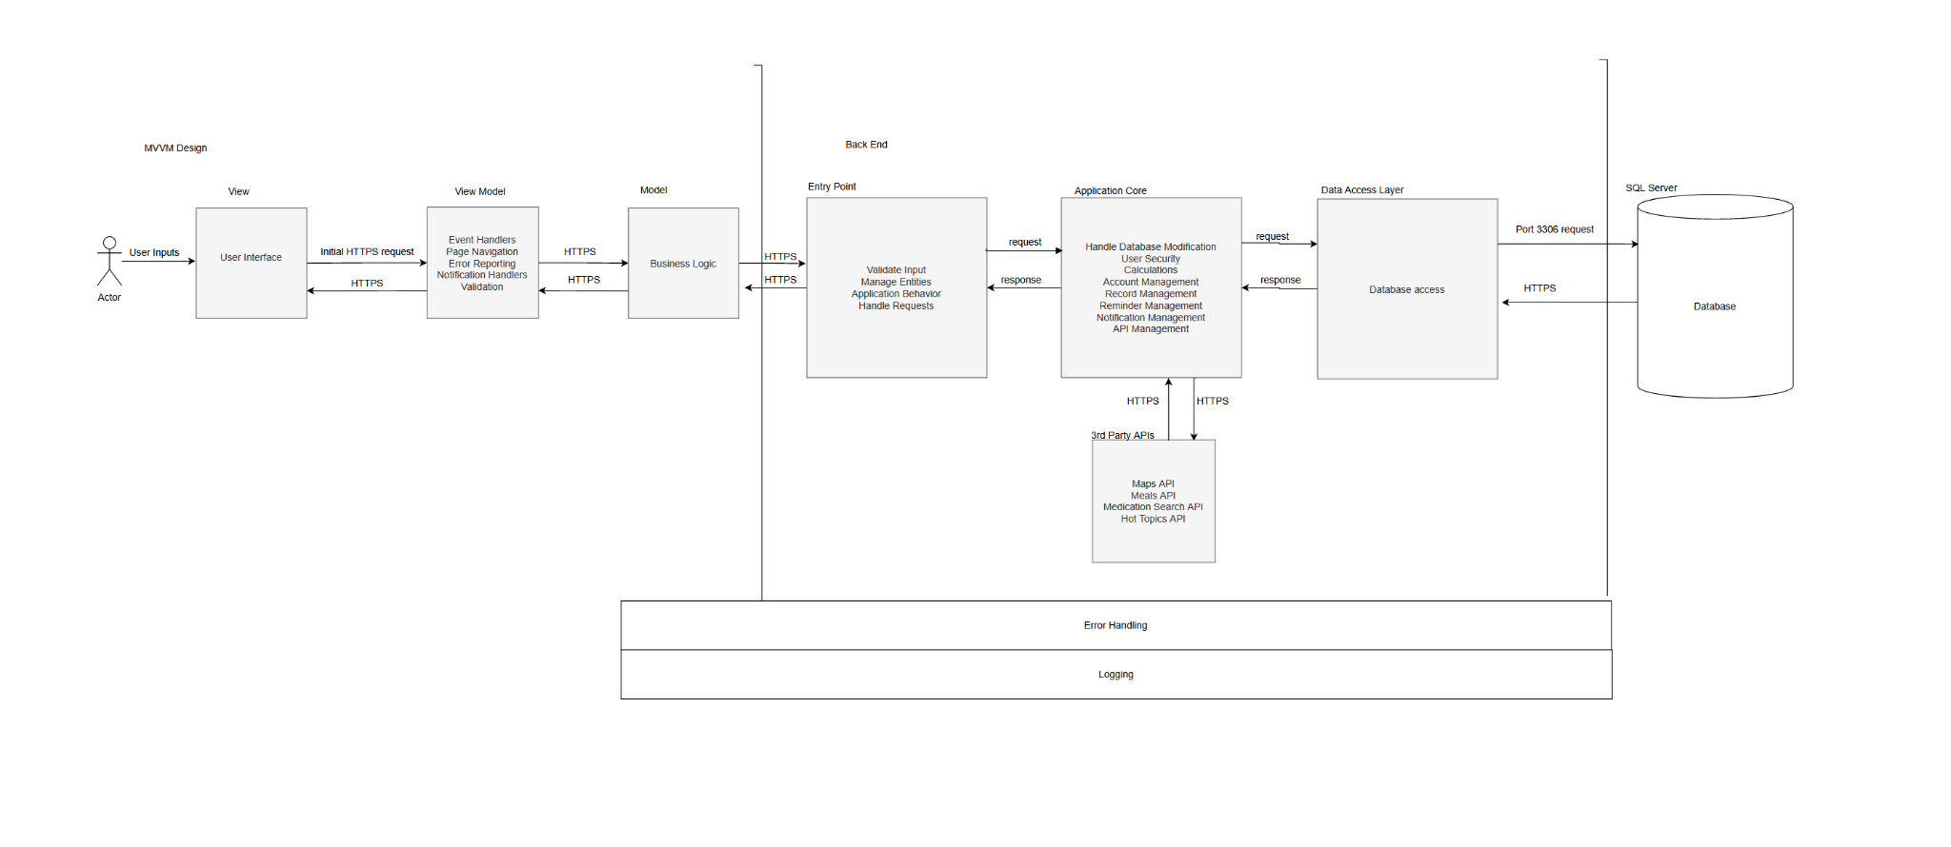

FrontEnd

View:

This is what the user sees when they load the website. This includes static content, which every user will see, and dynamic content, which will be user-specific.

Through the user interface, users will be able to access login, records, health locater, and all features we provide. Our UI will be made to be clear and easy for users to access as well as administrators. The View will be constantly changing as users utilize the many features of our application.

View Model:

The view model will handle all user inputs. The view model will handle events, such as users selecting a feature, navigation between pages, reporting any errors the user has made to them, and any notifications the user requested, such as reminders. The view model also handles page updates, as it will relay new information being sent in from the back end so it can be displayed to the user.

Back end

Entry Layer:

The entry layer works to make sure the flow of information from the front end to the back end is as concise as possible. All requests the user enters will go to the entry layer, which will decide what exactly the back end needs to do with the given request. This is also where the application will take care of validating inputs, to make sure all inputs entered are valid before entering the application core. If any input is invalid, it will not make it to the application core and will instead give the user an error.

Application behavior describes the flow of the program. The entry layer will take any information provided from the application core or from the front end and decide what needs to be done with the information. Some information will need to be managed by different aspects of our application core, while other aspects will not.

The entry layer will also decide how different parts of the application core will interact with each other through entry management. To reduce coupling and allow for easier future expansion, Everything in the application core will not be reliant on each other. Instead, they will receive all necessary information from the entry layer. This will allow for a simpler flow of information and for fewer development errors.

Application Core:

The application core does the bulk of the work regarding computation in regards to the information that we take in from our users. Our site takes in large amounts of data from users, and what is done with the data is handled by our application core making sure that we do it securely and efficiently. Account management will allow users to easily input all information and save users’ data. We will have constraints in place to ensure user security when transferring data between the user and our database. Security within our application will be very robust as we will abide by HIPAA guidelines to keep our clients’ information safe, such as passwords, records, and medications.

The application core will also handle communicating to all third-party data. BitOHealth utilizes different APIs to receive information such as medication search, to simplify our processes and reduce the workload on the database.

The application core will handle tasks that are needed when users utilize our many features. For example, calculations are a necessary component of the application. Calculations are necessary for features such as calorie counting, where the application core will calculate how many calories a user consumed on a given day. Records and reminders inside the database will be managed from this layer. Users are able to create, delete, edit, and view any records or reminders they have access to. Any records or reminders that require notifying the user will be handled by the application core to make sure all notifications are on time. For each of the features, error handling will be done to ensure the user does not input anything wrong and to ensure the web application does not break.

Hardware High-Level Design:

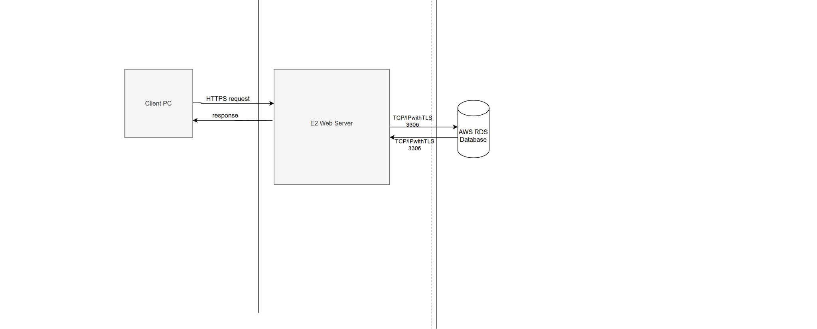

Front End

Client PC:

The client pc is the hardware that is being used by the user to access our website. Preferably it will be running Windows 10 OS with Chrome as its browser. The Client’s pc does not need to be very powerful, as a Raspberry Pi will be able to view our site. The client’s pc will work with the front end of our program. All inputs the user gives will be given through the client’s PC.

Back End

Web Server:

This is a server that will host our site and handle all computations and events that happen within the site. When a user triggers an event in the front end, it sends a request to our server which then will handle sending updates back to the front end. Web server will also handle messaging to the database. Everything that happens here will abide by HIPAA guidelines.

Database:

The database is where everybody's data will be stored. Ranging from Reminders, to personal medical documents. This will also be following HIPAA guidelines.

The database will be backed up by a backup database, in case of any issues within our database